Year 10 Science
Semester 1 Examination 2017 - Revision
Astronomy + Physical Science

Astronomy

1. Complete the following table.

TERM | DEFINITION
light year
constellation
galaxy
nebula
supernova
red giant
black hole
sunspot
corona
fusion

2. Light travels at 300,000 km/sec. A star is 97.6 light years away. We can only travel at about 15 - 20 km/second with our best rockets.

(a) With our current technology, are we likely to be able to travel to this star in the near future? Give a few reasons for your answer.

YES / NO (Circle your answer.)

Reasons: •

•

•

(b) Suggest one way we might be able to overcome the time factor of travelling to other galaxies, given it could be hundreds of years.

3. (a) What is the major element found in the Sun?

(b) What happens to this element so that the Sun produces its energy?

(c) The Sun loses 5 million tonnes of mass per second. According to Einstein's equation (E = mc²), what does this mass become?

4. How is the surface temperature of a star related to its colour?

TEMPERATURE | COLOUR
 | blue
 | red
 | yellow

5. (a) About how old is our Sun (in millions of years)? million years

(b) How much longer will it "live"? million years

6. (a) Draw a flow diagram (with arrows) to show the stages of our Sun's remaining life as it runs out of fuel.

Sun

(b) Do similar flow diagrams for the following types of stars.

Huge star

Giant star

(c) The difference between a nova and a supernova is the size of the explosion that takes place. What happens to a star to cause it to explode?

7. (a) Describe the size of the gravity near a black hole.

(b) Why does a black hole appear black?

8. Complete the following matrix to compare the Big Bang and Steady State Theories, using ticks to show which statements apply to one, both or neither theory.

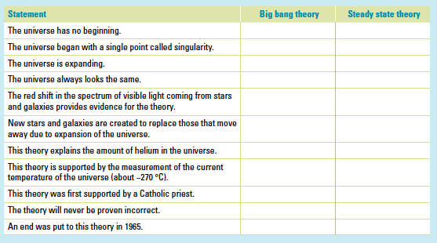
9. Why are the constellations we see now so different from the way they were many centuries ago?

10. How have scientists gained their knowledge of the life and death of stars if the processes involved take millions of years to occur?

11. What is the difference between a neutron star and a black hole?

12. What makes stars group together to form galaxies?

13. The Doppler effect is most commonly associated with the changing pitch of a sound as its source moves past you. For example, the pitch of the noise made by a speeding train increases as it approaches you and decreases as it moves away from you. Explain how the Doppler effect is relevant to the study of the universe.

14. What is cosmic microwave background radiation and why does it exist?

Physical Sciences

1. A man drives his car 800 m due East and then turns North, driving 300 m before stopping at a petrol station. It took him 120 s to get there.

(a) What distance he has driven.

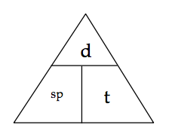

(b) Calculate his average speed for the journey.


2. A balloon filled with hydrogen gas has a velocity of 40 m/s East. How long will it take to go 450 m ?


3. What is the average speed of a plane if it flies 2700 km in 2.3 hours? Give the answer in km/h.

4. A top sprinter reaches 11.2 m/s within 3.15 s of the start of a race. Calculate the average acceleration.

5. Calculate the final velocity of a car initially travelling at 10 m/s that accelerates at
1.4 m/s² for 10 s.

6. Determine the average acceleration of a car that increases its velocity from 7.0 m/s to 34 m/s in 9.0 s.

7. A truck moving at 36 m/s is decelerated uniformly at 1.5 m/s². What is its final velocity after 5.0 s?

8. A car of mass 1530 kg is travelling at 70.0 km/h (19.4 m/s) along Hepburn Avenue when the driver has to brake sharply to avoid a small child who suddenly appeared on a bike crossing the road.

(a) If it took 3.5 s to stop the car, calculate the deceleration of the car.

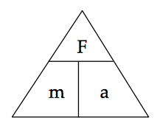
(b) Calculate the average force exerted by the brakes.

(c) The driver of the car was an engineer and had a hard-hat sitting on the back shelf. Describe what happened to the hard-hat in this situation and explain why it took place.

9. (a) Explain the difference between mass and weight. Give an example to help your explanation.

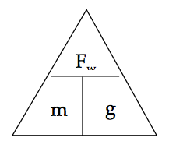
(b) The acceleration due to gravity on Jupiter is 22.5 m/s². Calculate the weight of a 450 kg object on Jupiter.

10. A 70.0 kg cyclist is applying a force of 150 N forwards but is working against the wind, producing a friction force of 80 N opposing the movement.

(a) Determine the resultant force for this situation.


(b) Calculate the acceleration of the cyclist.

(c) It is possible for the rider to move at constant velocity. In terms of the forces acting, explain how this is possible.

11 . You are sitting on a seat at the moment. Explain why you don't fall through the chair and are supported by it.

12. Use the scale in the map below to work out the distance and displacement from the Fairmont Empress hotel to Craigdarroch Castle. Use either the blue or grey route.

Remember to give a bearing or direction for the displacement.

